Design and Technology for Collaborage:
Collaborative Collages of Information on Physical Walls
Thomas P. Moran, Eric Saund, William van Melle,
Anuj U. Gujar, Kenneth P. Fishkin, Beverly L. Harrison
Xerox Palo Alto Research Center
3333 Coyote Hill Road, Palo Alto, CA 94304 USA
{moran,saund,vanmelle,agujar,fishkin,bharrison}@parc.xerox.com

ABSTRACT
a Collaborage is a collaborative collage of physically represented information on a surface that is connected with electronic information, such as a physical In/Out board connected to a people-locator database. The physical surface (board) contains items that are tracked by camera and computer vision technology. Events on the board trigger electronic services. This paper motivates this concept, presents three different applications, describes the system architecture and component technologies, and discusses several design issues.

Keywords
collaboration, roomware, physical-virtual, tangible UI

INTRODUCTION and motivation

A consistent theme in anthropological studies of the workplace is “the intimate relationship between work environments and the structuring of work activities” [21]. We are exploring one common feature of the workplace—the “technology” of physical walls.
Putting information on walls is a common practice in the workplace. Walls serve as persistently visible display surfaces where paper documents, clippings, posters, notices, computer printouts, handwritten notes, etc., are posted. The wall itself might be a writable whiteboard with items attached by magnets. In classroom settings, learning materials and the work of the students is posted. Many design practices use walls to gather up information and requirements from clients and to display design proposals for review. Within the context of a workgroup, information is posted to display the work of a group to outsiders, to share information among group members, to coordinate activities of the group, and to surround themselves in visible manifestations of the progress of their work. “Applications” of walls are In/Out boards, schedules, announcements, project task lists, timelines, calendars, maps, etc.
Several workplace field studies have shown the importance of physical walls. Whittaker and Schwartz [25] compared two software development teams, one using a software project coordination tool and the other using a 25-foot wall, with notecards representing tasks arrayed along a timeline on the wall. The study showed clear advantages of the physical wall. The wall was persistently visible and public. It was collaboratively constructed, and thus everyone had a stake in it (project members felt that posting a task on the wall engendered a public commitment). The wall was a locale for discussion. With the software project management tool, by contrast, the project manager entered the data and thus “owned” this representation of the project. It was usually invisible and was ignored by project members. Even the supposed advantage of automatic reformatting of the task chart was a disadvantage, because the constant rearrangement confused project members.
Bellotti and Rogers [1] found that physical walls were commonly used in the publishing industry. Even workers in software-savvy environments such as web design companies used physical walls to pin up web pages and taped yarn between them to map out the link structure.
However, physical walls do have disadvantages: they are only visible in one place, and their information is not easily related to online information, particularly to dynamic online information. Our goal is to combine the advantages of physical and online systems. We use unobtrusive vision technology to sense the information on the wall, to track changes on the wall, and to provide electronic services (e.g., remote viewing). The wall can thus become an interface to the electronic world by triggering processes, such as changing information in databases or sending notifications. We call such a sensed physical surface a Collaborage, a collaborative collage of physically represented information interacting with online electronic information and services.
One motivation for the Collaborage concept comes from our earlier studies of the Liveboard, a large electronic display technology. We based the user interface on a whiteboard metaphor; but we found that in addition to being able to scribble on the Liveboard, it was useful to provide users with arrangeable “domain objects” [15,16] that represent various meaningful items of work (e.g., cost items in a budgeting task). The domain objects were pulled from a database and presented to the users on the board for them to manipulate. We found that we were able to computationally interpret the spatial arrangement of the domain objects, according to the conventions of the task, and store these interpretations in the database. Similarly, we expect to be able to interpret the spatial arrangement of information on physical walls.
Collaborages on physical walls have many inherent advantages over electronic displays: they can be much larger; they are persistent (always “on”); they effectively create a public locale for interaction and collaboration; they are a “calm” technology [23]; and of course they are cheaper. We want to preserve these advantages in exploring the Collaborage concept. The aim of this research is not to turn the physical wall into an electronic display, but rather to understand the nature of the tradeoffs.
Figure 2. Web Browser View of Part of the
In/Out Board.
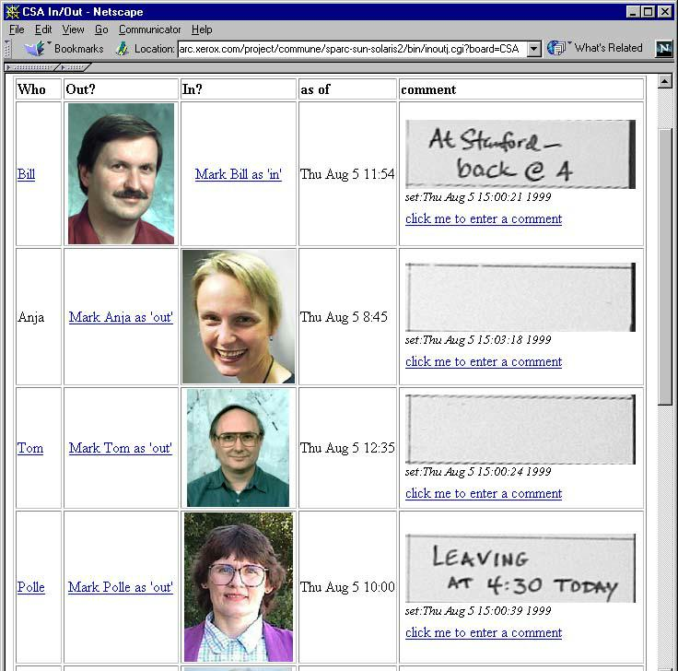
Other researchers in HCI are also exploring the advantages of linking a surface-rich physical environment with the electronic world. There is considerable work exploring linking paper to electronic information [4,7,9]. Expanding from the page to the desktop, one of the earliest prototypes is the DigitalDesk [24], which uses both cameras and projection to intermix physical and displayed information. Other desk applications include metaDesk [6] and Video Mosaic [11]. Expanding from the desk to the larger physical environment, including walls, the Insight Lab [10] uses barcodes to link information on walls and paper to electronic information. This is perhaps closest in spirit to the Collaborage work. Some researchers are also exploring ideas similar to ours about tagged elements on interactive displays, such as the HoloWall [12] and the transBoard [6]. Finally, a contrasting view is that physically created information will be supplanted with video projection techniques to cover the physical environment with information [17].
Figure 1. Hallway Wall with In/Out and Away Boards.
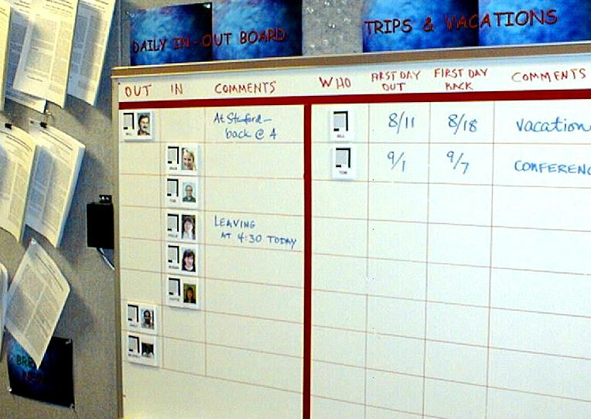

Collaborage SYSTEM OVERVIEW
A Collaborage system consists of a board (e.g., a tackboard on a wall), on which various physical informational items (e.g., papers) can be arranged. The two critical features of each item are its 2-D location on the board and its unique identifier (UID), encoded by a tag. A Collaborage event is the appearance, disappearance, or movement of an item. The Collaborage system recognizes these events and triggers application-specific services based on them.
The system has both hardware and software components. The hardware consists of a controllable pan-tilt camera connected to a frame grabber on a computer. The main software component is the Board Observer Server (BOS), which tracks the items on the board. Item tags are visually distinctive dataglyphs [3] (similar to barcodes) that are decodable by zooming in with a camera. The BOS reports Collaborage events to a Dispatcher, which routes them to Applications, which perform appropriate computational services.
We have built a complete version of the system—boards, tags, BOS, Dispatcher, and initial Applications—to demonstrate the technical feasibility of the Collaborage concept and to explore design and technology issues.
In this paper we first describe three applications to motivate the utility of the system and to show the various components in action. Then we describe the system architecture and technologies in detail. Finally, we discuss several system and design issues.

APPLICATIONS of Collaborage
We developed three different applications to exercise the basic system capabilities and to show different kinds of uses for information on a wall. The first is an In/Out and Away Board on which group members indicate whether they are in or out of the building and when they will be away on trips. The second application is a Project Task Wall, on which a group keeps the current status of active tasks in a project. These two applications use tagged items as data elements; the third application uses tags as command elements to control the capture of information on a whiteboard.

In/Out and Away Board
Figure 3. Project Task Wall.
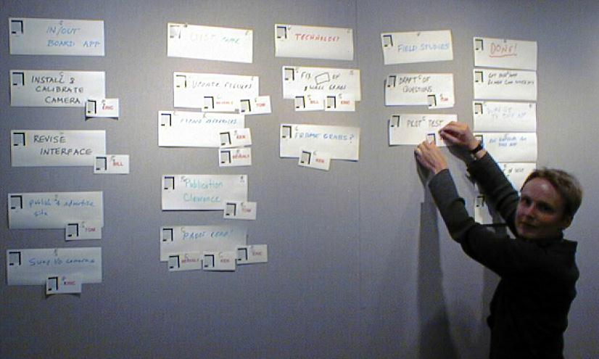
Figure 4. Items on Project Task Wall.
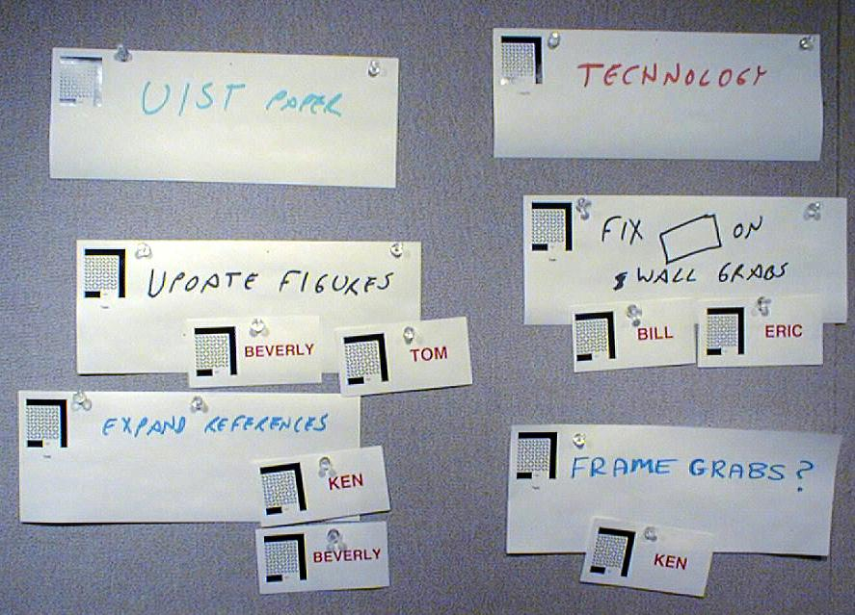
In/Out boards are common in office settings. Each person in a group has a token that they move on a board when they arrive and leave to tell others whether they are in or out of the office. In our case, the In/Out and Away Board is located in the hallway where members of our group pass by on their way to and from their offices (Figure 1). The board is a 4 x 3-foot whiteboard with lines defining a tabular format, consisting of two side-by-side tables. The left side is the In/Out table, which has three columns (In, Out, Comment) and a row for each person. Each person has a “badge,” a badge-like Collaborage item with their name, picture, and a glyph tag, which magnetically attaches to the board. People move their badges between the In and Out columns and optionally write in the Comment column (e.g., “leaving early today”). The Collaborage system tracks this activity and informs the In/Out Application program. The In/Out Application interprets the locations of the badges and updates a database. It also takes snapshots of the Comment regions and puts these in the In/Out database. A separate program, a cgi script, makes the In/Out information available via a web browser (Figure 2), so that people can view the In/Out status from their offices or from home. Not only is the In/Out information kept, but also the time at which the In/Out status last changed is noted. From the web browser view, people can change their In/Out status, and they can add textual comments in addition to the scribbled comments on the physical board. Thus, there is more information available in the web view than on the physical board—the web view and the physical view can be considered as two different views on a common “underlying” database.
The Away Board works somewhat differently. There are four columns (Who, First Day Away, First Day Back, and Comments). Each row is for noting a trip. There is a set of person badges on the tray under the board. To record an upcoming trip, the user takes one of their badges and puts it into the Who column of some empty row, then writes dates in the next two columns, and a comment in the last column. If more than one person is on the trip, then multiple person badges can be placed in the same row. Similar to the In/Out Board, the Away Board is tracked by the system, and the changes are fed to the Away Application, which puts the information in a database, where a web browser can display the information to remote users.
Extensions. These applications are simple for a small group, where all the information fits onto a single board. Keeping such information local to each group is an advantage. A useful extension would be to have many such local In/Out/Away boards feed into a common database. The web browser could then provide different displays of the information sorted by person or by group.

Project Task Wall
Project coordination is the domain of one of our motivating studies [25]. Our Project Task Wall Application is based on our group’s practice of posting currently active tasks on the wall during weekly group meetings. This supports both the reviewing of the previous week’s activities and planning tasks for the coming week.
The Project Task Wall is located in the group’s meeting room. The wall is a 16-foot-wide, full-height tackboard (see Figure 3). Three different kinds of items are posted on the wall. The principal items are tasks, which are handwritten on 11x4 inch cards. The tasks are organized into activity categories, which are represented by “category” items. Category cards are usually placed along the top of the board. Tasks are posted in columns beneath the category cards. Finally, there are badge-size person items. These are posted next to the Task items to indicate which people are responsible for the different tasks. Figure 4 shows such an arrangement of items.
The Collaborage system tracks the items on the board and builds a database of tasks. The database records the location of each item and the captured images of the handwritten information on the task and category cards (people badges are created for specific people, with their names preprinted). The Project Task Application then interprets the spatial arrangement to assign a category and people to each task.
Figure 5. ZombieBoard Image of Project Task Wall.
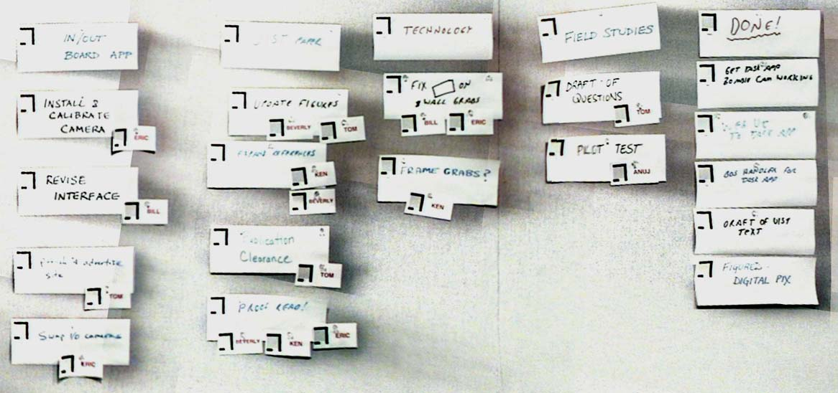
Figure 7. Large Whiteboard, with request to snap area within bounding brackets.
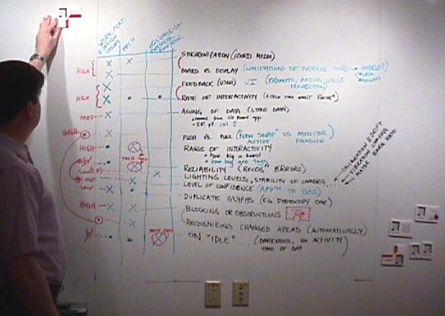

Application programs were built to present the Task Wall information on the web. The first view presented is an overall picture of the Task Wall, obtained using the ZombieBoard system [19]. It does this by taking an array of snapshots and then stitching them together into a single, normalized image (see Figure 5). From this view one can then request that the task information be presented in other organizations, depending on what the user needs. For example, the tasks can be presented sorted by person, so that people can refer to the tasks they are responsible for. Figure 6 shows such a task listing.
Extensions. This particular Task Wall Application was tailored to a specific work practice. It would be easy to alter the application for other practices. For example, time information could be incorporated by having the horizontal dimension represent time (as in the [25] case). Instead of category items, there could be temporal items along the top of the board. The horizontal position and extent of each task card could then indicate the planned time for the task. This information could then be integrated into standard project planning software packages.

Whiteboard Controller
The third application is quite a bit different. Information is written on the wall, not on the items themselves. We take advantage of the technology of tagged items on walls to control the capture and processing of information written on a whiteboard. The tagged items thus function as a command language.
The whiteboard in question is a ZombieBoard [18,19], mentioned above in the description of the Project Task Wall. The ZombieBoard technology captures images of large whiteboards by stitching together arrays of smaller images captured by camera. Capture is triggered by a “Diagrammatic User Interface” (DUI) in which the user draws or places a specific icon (an X in a double box) on the board, where the DUI notices it. The Collaborage BOS is an extension of the ZombieBoard perceptual user interface technology, so we decided to use the new capability to give the user finer control.
Figure 6. Partial Web Browser View of Tasks
Sorted by People.
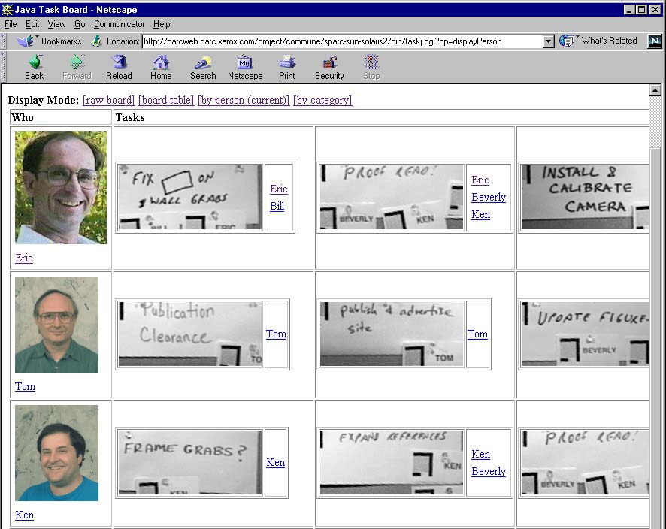
The control items are magnetized, tagged icons. They are stored in a neutral “parking” region on the side of the whiteboard, where the system interprets them to be inactive (thus, when we refer to items being on the board, we mean that they are not in the parking region). The principal control item is the Capture icon. When this is placed on the whiteboard, a capture of the whole whiteboard is triggered, just like the basic ZombieBoard.
However, there are many other control icons that serve as arguments to the Capture command. There are two L-shaped Bracket icons, which limit the capture to the rectangular region marked by the Brackets. A single Bracket can be used alone to specify the corner of a region that extends to the edge of the whiteboard. In all these cases the captured image is sent to a standard repository, where it can be accessed by the place and time of capture. The captured image can also be directed to other destinations. There are several Printer icons. When any of these is placed on the board, the image is sent to the designated printer(s). Person badges can be used as control items. When these are on the board, the image is emailed to the designated people. Finally, there are Topic icons. Each Topic is associated with a location in a repository (e.g., a project folder), where the captured image is sent when the Topic icon is on the board. Figure 7 shows a ZombieBoard, and Figure 8 shows a closer view of the control icons.
The command language for using these icons is as follows. The user must place all the argument icons on the board (in any order), then place the Capture icon, and then get out of the way. When the system detects the Capture icon, it gathers all of the arguments; and then initiates the camera scan of the designated region. When the camera scan is finished, it gives an audio signal. At this point the user can use the board again, while in the background the system processes the raw camera images into a composite image and dispatches it according to the argument icons present.
Figure 8. Close-up of Whiteboard Showing
Command Icons.
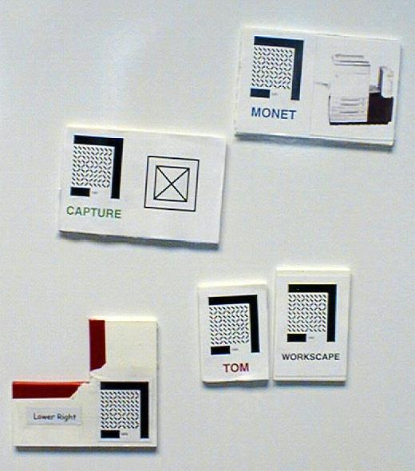

Collaborage system architecture
Figure 9. Collaborage System Architecture.
The Collaborage system consists of a board with a collage of tagged items. The activity of the items on the board is tracked with a camera. The software architecture behind the camera is shown in Figure 9. The BOS senses glyph events and reports them to the Dispatcher, which in turn reports them to interested Applications. The architecture is designed to accommodate a variety of sensors (such as RF-based tags [22]) and actuators in the physical environment of the Collaborage board. The components of the Collaborage architecture communicate through ILU [8], a multi-language object interface system. The goal of the architecture is to make it easy to write Applications that meld the information and activity of the physical world of the board with the world of electronic information.
The components of the Collaborage technology and architecture are described here in a bottom-up fashion, from the tags on the board to the applications. We start with the tagging technology and then proceed to the BOS, the Registry, and the Dispatcher.

Tagging Technology
For tags we are using dataglyphs (or glyphs for short) which are a 2-D data encoding technology, similar to barcodes [3]. Data is encoded in the orientations of diagonal elements (see Figure 10). Glyphs were originally designed and are normally used for encoding data on paper documents scanned at a resolution of at least 300 dpi [3], where glyphs are typically printed at a density of 30x30 elements per square inch.
For Collaborage, we designed a coarser glyph pattern that would be visible when zoomed in on from an NTSC-resolution commercial pantilt camera, such as a Sony EVI-D30 (maximum focal length 64 mm), mounted at least 15 feet away from the wall surface. Collaborage glyph tags employ a 9x9 pattern of elements in a one-inch-square area. One row and one column of the square glyph pattern are devoted to a fixed synchronization code, leaving 8x8 or 64 bits of raw data. We employ a highly redundant error correction code delivering 20 bits of actual data, or about one million distinct glyph IDs.
We need to be able to detect the location of glyphs on the board when the camera is zoomed back to see the entire surface at once. Therefore, we surround each glyph data field with a localization pattern (see Figure 10). This was designed to maximize detectability of the glyphs in camera images of the entire wall, while minimizing false hits. In such a zoomed-back, low-resolution image, a glyph tag appears at a size of about 15x15 pixels. A fast template matching algorithm using the Hausdorff distance measure is used to localize glyph tags in the image [5].
Glyph tags remain detectable in low resolution and decodable when zoomed in on only when they are entirely visible (not occluded) and as long as they are not tilted more than 15 degrees. Our current implementation parameters support a Collaborage board up to about eight feet wide and 4.5 feet high. The board size that can be covered by one camera depends on many factors, including camera placement, frame resolution, camera pointing accuracy, lighting, and tag size. Larger boards could be enabled by using larger glyph elements and/or a larger tag localization pattern.
The accuracy of glyph detection seems to be good enough for practical tasks. For example, we have been running the In/Out Board continuously for months, and the only recognition errors are occasional false positives (which add some processing time, but no “content” errors). However, the system does have limiting conditions—large board size, skewed camera angle, poor lighting—which can cause the system to occasionally fail to sense glyph tags present on the surface. Thus, a critical part of setting up a new board is verifying that these limits are not overreached.

Board Observer Server (BOS)
The Board Observer Server provides the core enabling computer vision technology underlying our implementation of Collaborage. It is an extension of the ZombieBoard system [18,19]. The BOS’s job is twofold. First, it actively observes the wall scene, watching for changes in the status of glyph tags, and reporting these events to the Dispatcher. This involves monitoring the locations of glyph tags with the camera in a zoomed-back position, noticing when the configuration changes, then zooming in to read and/or verify the glyph pattern signifying a tag’s identity. Second, the BOS services requests from application programs to capture images of regions of the board.
Figure 10. Example of a Collaborage Dataglyph
(Actual Size).
Keeping track of the locations and identities of a large collection of objects on a wall is a task inherently fraught with uncertainty. Because objects can be positively identified only in a high-resolution image obtained by zooming in the camera, the system can be certain about the identity of any given glyph tag only at the moment a zoomed-in view is obtained and decoded. The rest of the time, tag locations and identities are simply best guesses. For example, suppose in the low-resolution view a glyph tag disappears for a few seconds, then reappears in the same place. This could easily be due to a person strolling by, leaving all the glyphs tags right where they were. On the other hand, the person could have swapped the glyph tag in question for another in the brief time it was not visible to the camera. To test this possibility, the system would ideally zoom in and verify the tag’s ID when it again becomes visible. This is obviously a safe choice of action when only one glyph tag is in question, but consider a board filled with tags. The BOS is continually faced with a complex array of uncertainties all demanding access to one limited resource, namely, where to direct attention from moment to moment.
Our approach to managing these competing demands is to assign each known tag a certainty, or confidence level, ranging from 0 (no confidence) to 1 (absolute certainty). Confidence is set to 1 when the glyph ID is actually decoded in a zoomed-in view. Henceforth confidence can only decay, until another zoomed-in view is obtained. The decision as to where to look next is simple: zoom in and check on the glyph tag with the minimum confidence, until all glyph confidence levels lie above a threshold. As long as this latter condition holds, keep the camera zoomed back and continue to verify all glyph tag locations in the full board view.
One advantage of this strategy is that confidence can decay not at a uniform rate but at a rate proportional to the likelihood that tags’ identities on the board may have diverged from the system’s internal model. In particular, confidence decays slowly as long as successive zoomed-back images of the board continue to verify that glyph tags are found at all locations where they are expected. In a static scene the camera spends most of its time zoomed back, verifying glyph tags’ locations, only occasionally zooming in to verify IDs.
When the board is in use by people, however, the camera must become more active. Confidence in a glyph tag decays more rapidly if it becomes unseen in the low-resolution view. This can happen for a number of reasons, each of which suggests a different decay rate. First, if the region of the scene where a glyph tag is expected to appear exhibits motion activity (as determined by frame differencing and other techniques) then it is likely that a person is moving around in front of the tag. This provides a plausible explanation for the tag’s absence from the low-resolution image, and implies that a moderate confidence decay rate should apply during this period. If on the other hand the scene is stable (no activity) then the tag is unlikely to simply be occluded from view and more likely to have been removed from the board. Confidence decays rapidly, leading the system rather quickly to zoom in and check on this glyph tag. Finally, when the camera is busy zooming in to check on one or more glyph IDs, then the interval between low-resolution views is greater. There is more chance that other glyphs could have been moved around while the camera wasn’t looking; confidence during this time must decay at a somewhat more rapid rate.
This overall strategy is embedded in a state transition logic that takes account of false positive and false negative sensor measurements due to inevitable occasional failures of glyph decoding and Hausdorff glyph location detection. This logic further handles ways in which measurement of one glyph’s identity can affect the beliefs in other glyphs’ identities. For example if a user suddenly swaps around the locations of several glyph tags, then as soon the camera zooms in to verify one of them it will discover a tag ID different from the one it expected. This can cause a chain reaction of rapid belief decay and checking until the system’s internal model of the board state comes back into alignment with sensor measurements.
The typical cycle time for our implementation is about 8-10 seconds per low-resolution capture and analysis, and 5-10 seconds to zoom in and decode a glyph tag. The time to report, say, the movement of a glyph tag from one location to another depends mainly on the state of the system’s confidence levels with respect to the entire set of glyph tags in view. If a small board is empty of glyph tags, the first one placed can be reported within 10 seconds. If on the other hand the system is busy checking on glyph tags that have been rearranged or temporarily obscured in some other part of a large board, it can take up to a minute to catch up with a tag’s movement. Most of this time is spent performing image processing tasks and could be sped up considerably through use of a faster computer. The limiting time required to point and zoom the camera ranges from 2 to 6 seconds per location inspected, including a one second timeout period to allow vibrations in the camera mounting hardware to settle out.
In addition to its function as a board observer, the BOS takes time out from this duty to capture images on demand as requested by applications. Typically, an application will request that a series of overlapping, moderately zoomed-in snapshots be taken that capture a board region at higher resolution than could be obtained from a single zoomed-back view. These are then stitched together to assemble an image mosaic of the region in question, using the ZombieBoard routines [18].

Registry
The system maintains a persistent registry of Collaborage items. Whenever an item is created (for example, by a dataglyph printer), information about it is entered into the registry. When an application receives an event referencing an item, it consults the registry to find the relevant details about it.
Each item is described by an attribute-value property list. All items have the attribute item-type; other attributes are application-specific. All items tagged by dataglyphs have an attribute glyph-ID, which the Dispatcher uses to associate an item with an incoming event.

Dispatcher
The Dispatcher conveys events from various sensors, such as the BOS, to Applications, such as the In/Out Board. An event is simply a property list of attributes and values. All events have the attributes type and time; other attributes depend on the type of the event. For example, all events generated by the BOS include an attribute identifying the board being observed; most of them also contain a glyph-ID attribute and an XY location.
Applications register interest in a class of events by giving the Dispatcher an event pattern, which is an arbitrary Boolean combination of conditions on the attributes and values in a desired event. Conditions include equality, inequality, and regular expression match.
When the Dispatcher receives an event, it first checks to see if it includes a “tagging” attribute, such as glyph-ID. If so, it looks up the value of the attribute in the registry to find the item associated with the tag. If it finds one, it adds an additional attribute to the event giving the item’s UID, which an application can use to look up the item’s full property list. Finally, the Dispatcher sends the event to the Applications whose previously-registered event patterns match the event.

discussion
Implementing the Collaborage technologies and creating the applications has raised a host of issues. We discuss these issues from the user’s point of view and relate the underlying technological issues.

Interactivity Issues
Rate of Interactivity. A Collaborage board is not an interactive display. It takes the system at least several seconds, as we have noted, to react to a user action on the board. This is adequate for many applications, such as the In/Out and Away Boards and the Project Task Board, where a change of state does not have to be recorded instantly. We need to consider the time cycle of interactivity needed for any task to determine whether the Collaborage technology is suited for the task.
We have encountered this issue in the Whiteboard Control Application, when the user puts up the Capture icon and it takes several seconds for the system to respond. There are several stages to the system’s response to the user action in this case: (1) It notices the Capture icon. (2) It waits for all activity at the board to stop to be sure that it has a stable state, and thus has all the argument icons correctly identified. (3) It scans the board with the camera to capture the requested region. (4) It processes the captured image as requested by the arguments.
While it takes only a few seconds for stage 1, stage 2 can take much longer, because stability takes time to determine. For example, when a glyph disappears from view, the BOS can’t decided whether it has been removed until it has determined that the entire board is stable and confidently known, since otherwise the glyph could have moved to a place where it is temporarily obscured by someone in front of the board. This means the user has to be careful to stand back from the region to be captured. This apparent “fussiness” is not a problem in this kind of application, as over two years of ZombieBoard [19] experience has shown.
Feedback. It is crucial to give the user feedback about the system’s progress. Currently, we give the user audio feedback after stage 3. This is an important point in time, because the user can then resume use of the board. However, we could also give feedback during stage 2, if it takes too long, telling the user to stand away from the board. At the end of stage 2, we could remind the user to not obscure the designated region of the board. Such feedback is important to help the user understand the time delays. But it is also important because the user and the materials are physically intermingled, and the user can be guided to behave more effectively.
Physical Range of Interactivity. A final interactivity issue is the size of board on which the system can detect glyph activity. We would like more than the 8 feet that we can currently get (e.g., the command icons cannot be detected on the edges of our 12-foot whiteboard). One approach to handling large boards would be to use multiple cameras with coordinated BOSs.
Hardware Phicons. We have surveyed various technologies (e.g., RF, GPS, ultrasonics) for locating objects. Given our requirements for economically and accurately locating (within about an inch) a large set of objects on any surface, vision technology—camera plus image processing—is the only currently workable technology. This only requires passive tags, such as glyphs, that are visually distinct. However, we have also explored IR-based hardware tags, which we called phicons, to try to improve interactivity (reported in [13]). These phicons can be detected faster than glyphs, because they send out time-sequenced IR signals that can be decoded by a camera without requiring it to zoom in. But it should be noted that these phicons are also subject to the interactivity issue of obscured line-of-sight to the board and thus of having to wait for a stabilized state (stage 2 above).

Explicit Commands vs Implicit Use
Another design issue is whether to regard the Collaborage board as an interface to give explicit commands to or as just a board to use (to post and arrange information). The In/Out Board is a place to mark oneself as being In; one does not “command” the system to recognize that one is In. On the other hand, one does command the system to capture the Whiteboard. In the Project Task Board, we could go either way: we could have a Capture icon tell the system to record the state of the tasks after a meeting, or we could just have the system track the changes as they happen and not explicitly tell the system to capture the state. We decided to do the latter, since there was no reason to give an explicit command.
The spirit of the Collaborage design clearly implies an implicit use model. However, an explicit commanding model is often useful. And the two models can be mixed.
An example of mixed use arises in the In/Out Board. The information posted on the In/Out Board can be wrong, since people sometimes forget to move their badges as they come and go. It is impossible to tell whether this is the case by looking at the physical wall. However, the timing information can help one interpret the information in the web view. For example, if Bill’s status is In, and it was set today, then we infer that he is actually In. But if it was set yesterday morning, then we can infer that Bill probably forgot to mark himself Out yesterday when he left; and we cannot be sure whether he is actually In today. Now, suppose that Bill comes in and notices that he is already marked In, because he forgot to mark himself Out yesterday. If he wants to “refresh” the information in the database to indicate that he is really In today, he can first mark himself Out and then In. However, since the system takes a few seconds to recognize that a badge has moved, it is tedious and unreliable to make this double move. The solution we have adopted is to keep a couple of special “Update Me” icons on the board. In this case Bill simply moves an Update Me icon to his row on the board; the system notices this and changes the timestamp on the information in that row. The Update Me icon is an example of an explicit “meta-command” on a board that is predominantly implicitly used.

Uses of Image Recognition
Now that we have the basic glyph recognition and image capture capabilities in place, we can see several uses for image recognition capabilities.
It would be very useful to notice when a region of the board has changed, e.g., that someone has written or erased a comment on the In/Out Board, or annotated a Task card on the Project Task Board. Such changes could be detected by clever image differencing. If such changes were reported as Collaborage events, then handwritten comments could be timestamped in the database, which makes them more interpretable. Without change detection, we have to retake the snapshots periodically, at a frequency that fits well with their likeliness to change. While this keeps captured images updated, it gives no hint about when they were originally written on the board.
Several other recognition services could be used. If we could recognize handwritten dates on the Away Board, then we could put the trip information into a calendar and put it into the online version of the In/Out Board as comments. If we could detect edges of paper items, then we could have variable-size items, such as variable length Task cards in the timeline version of the Project Task Wall (currently, item sizes must be registered). Line recognition would allow us to dynamically change board regions by moving linear boundaries. Also line recognition would allow us to interpret links (e.g., made with pieces of yarn) between items, as in the web site example [1].

Coordinating Media
The In/Out, Away, and Task data now exist in two media, on physical boards and in the electronic databases, neither of which is a subset of the other. From the user’s point of view, we might well ask: Where is the real data?
The electronic medium is more than just a captured image of the board, since the user can interact with the browser and change the database, and these changes are not reflected on the board. On the other hand, the board may contain information that is not captured by the system; e.g., the user might post non-tagged items that the BOS cannot detect and hence the Application does not know about. Thus, information in the two media can not only be different, but also be inconsistent (e.g., a user in her office notices that she forgot to check In on the board and does so now in the browser).
We have to be careful in how applications are designed and how boards are used. User expectations and work practices must also be designed and accounted for [2].

Is It a Board or Is It a Controlled Display?
The Collaborage board is, at present, only an “input device”; it is not an electronically controlled display. However, it would be useful to display some remotely generated information on the board to help coordinate with the electronic information. For example, it would be useful to do something as simple as displaying that certain people badges on the In/Out Board were inconsistent with the electronic database.
Such a function requires small, light, inexpensive, low-power display devices, but such devices need not present a lot of information to be useful (e.g., only one bit to represent each badge in the In/Out Board case). We are experimenting with various simple display components (e.g., LEDs or LCDs) that can be combined with miniature processing and communication technology to become part of our Collaborage board. The IR phicons of [13], which contain a small LCD, are a possibility. We have also tried black and white electric paper, using low-power driver electronics, a solar cell, and a low-powered laser pointer to change its state from a distance. Future low-power display components may even include MEMS-based reflectors.
We also experimented with a video projector on the board, which has the advantage of very flexibly displaying information in a variety of ways. A projector might be appropriate in a limited work session; but we found it to be much too “intense” for a persistent wall, turning the wall from a background information source to a center of attention.
In doing these experiments, we keep foremost in mind that we are not trying to turn physical walls into elaborate “Christmas light” displays or electronic panel displays, but rather are trying to preserve the simplicity and physicality that makes walls fit into their work settings.

conclusion
We are exploring the design space of large physical displays with modest electronic augmentation. We have implemented a running version of a complete Collaborage system, and we have designed and built three different kinds of applications as a proof of concept. Several design issues are emerging concerning the nature of the Collaborage board and its interactivity properties, the relation of the board to the associated electronically stored information, and the potential for more sophisticated services based on image recognition capabilities. We are just now in the position of being able to put Collaborage applications into situations of real use, where we can probe these issues more deeply.

ACKNOWLEDGMENTS
We thank Robert Bryll, who worked with us on the computer vision technology [14]. We thank David Hecht and Noah Flores for supplying us with glyph-decoding programs and William Rucklidge for Hausdorff template-matching code. We thank Roy Want, Darnell Moore, Ed Richley, and Tom Breuel for helping with various hardware experiments [13], and Anja Eichler for collaborating on related empirical studies [2].

REFERENCES
- Bellotti, V., & Rogers, Y. (1997). From web press to web pressure: multimedia representations and multimedia publishing. Proceedings of CHI’97, 279-286.
- Eichler, A., Jordan, B., Harrison, B. L., & Moran, T. P. (1998). Supporting planning and coordination in project teams: design implications from a field study. Xerox PARC, Working Paper.
- Hecht, D. L. (1994). Embedded data glyph technology for hardcopy digital documents. SPIE Color Hard Copy and Graphics Arts III, 2171(Feb), 341-352.
- Heiner, J. M., Hudson, S. E., & Tanaka, K. (1999). Linking and messaging from real paper in the Paper PDA. Proceedings of UIST’99
- Huttenlocher, D. P., Klanderman, G. A., & Rucklidge, W. J. (1993). Comparing images using the Hausdorff distance. IEEE Transactions on Pattern Analysis and Machine Intelligence, PAMI-15 (9), 850-863.
- Ishii, H., & Ullmer, B. (1997). Tangible bits: Towards seamless interfaces between people, bits and atoms. Proceedings of CHI’97, 234-241.
- Ito, N., et al. (1999). TransWorld: Paper world as avatar of electronic world. CHI’99 Extended Abstracts, 206-207.
- Janssen, W. (1994). ILU manual. Technical Report, Xerox PARC. ftp://parcftp.parc.xerox.com/pub/ilu/ilu.html
- Johnson, W., Jellinek, H., Klotz, L., Rao, R., & Card, S. (1993). Bridging the paper and electronic worlds: The paper user interface. Proceedings of InterCHI’93, 507-512.
- Lange, B. M., Jones, M. A., & Meyers, J. L. (1998). Insight Lab: An immersive team environment linking paper, displays, and data. Proceedings of CHI’98, 550-557.
- Mackay, W. E., & Pagani, D. S. (1994). Video Mosaic: Laying out time in a physical space. Proceedings of Multimedia’94, 165-172.
- Matsushita, N., & Rekimoto, J. (1997). HoloWall: Designing a finger, hand, body, and object sensitive wall. Proceedings of UIST’97, 209-210.
- Moore, D. J., Want, R., Harrison, B. L., Gujar, A. U., & Fishkin, K. (1999). Implementing phicons: combining computer vision with infrared technology for interactive physical icons. Proceedings of UIST’99.
- Moran, T. P., Saund, E., van Melle, W., Bryll, R., Gujar, A. U., Fishkin, K. P., & Harrison, B. L. (1999). The ins and outs of collaborative walls: demonstrating the Collaborage concept. CHI’99 Extended Abstracts, 192-193.
- Moran, T. P., van Melle, W., & Chiu, P. (1998). Spatial interpretation of domain objects integrated into a freeform electronic whiteboard. Proceedings of UIST’98, 175-184.
- Moran, T. P., van Melle, W., & Chiu, P. (1998). Tailorable domain objects as a meeting tools for an electronic whiteboard. Proceedings of CSCW’98, 295-304.
- Raskar, R., et al. The office of the future: A unified approach to image-based modeling and spatially immersive displays. SIGGRAPH’98, 1-10.
- Saund, E. (1997). Image mosaicing and a diagrammatic user interface for an office whiteboard scanner. Working paper, Xerox PARC. http://www.parc.xerox.com/saund/papers.html
- Saund, E. (1999). Bringing the marks on a whiteboard to electronic life. Proceedings of CoBuild’99 Workshop on Cooperative Buildings. Heidelberg: Springer.
- Streitz, N., et al. (1999). i-LAND: An interactive landscape for creativity and Innovation. Proceedings of CHI’99, 120-127.
- Suchman, L. (1997). Centers of coordination: A case and some themes. In Resnick, L. B., Säljö, R., Pontecorvo, C., & Burge, B. (Eds.), Discourse, Tools, and Reasoning: Essays on Situated Cognition (pp. 41-62). Berlin: Springer-Verlag.
- Want, R., Fishkin, K. P., Gujar, A. U., Harrison, B. L. (1999). Bridging physical and virtual worlds with electronic tags. Proceedings of CHI’99, 370-377.
- Weiser, M., & Brown, J. S. (1997). The coming age of calm technology. In P. J. Denning & R. M. Metcalfe, Eds., Beyond Calculation: The next fifty years of computing (pp. 75-85). New York: Springer-Verlag.
- Wellner, P. (1993). Interacting with paper on the DigitalDesk. Communications of the ACM, 36(7), 86-96.
- Whittaker, S., & Schwartz, H. (1995). Back to the future: Pen and paper technology supports complex group coordination. Proceedings of CHI’95, 495-502.

Although researchers are now beginning to explore large electronic walls, such as in the I-Land environment [20].
The glyph tags can be seen as a stylized version of the ZombieBoard’s DUI. What the Collaborage system adds is a framework to program the controls in a manner consistent with other Collaborage applications.
In fact, the components of the Collaborage system are written in different languages—C++, Python, and Java.
Rectangular shapes in different aspect ratios have been designed but are not currently in use.
One could also lower the threshold of detecting glyph tags in the Hausdorff matching stage, at the cost of more false-positive, or accidental, matches with other material in view, which would lead to less efficient use of the camera's attention and slower response to changes.
Even with this timeout, it is important that the camera have a stable mounting, else it will continue to vibrate, producing fuzzy images and excessive glyph recognition failures.
The glyph-ID is different from the item’s UID, because the system is designed to accommodate a mixture of different kinds of tags, such as E-tags [22]. In fact, the same item can be tagged with multiple tags, all of which map to the same UID.
Our phicons have buttons. These can be used to send signals directly to an IR receiver, bypassing the camera altogether [13]. Thus the buttons could be used for commands that do not require a spatial location.
One possible reason to have an explicit command would be to checkpoint a particular state of the board.

